

MEDINA MUNICIPAL COURT

2020 ANNUAL REPORT

GARY F. WERNER

presiding Judge &

administrative judge

joseph f. salzgeber

CLERK of Courts

135 North Elmwood Avenue

Medina, Ohio 44256

*Proudly serving the communities of Brunswick Hills Township, Brunswick City, Chatham Township, Chippewa Lake Village, Granger Township, Hinckley Township, Lafayette Township, Litchfield Township, Liverpool Township, Medina City, Medina Township, Montville Township, Spencer Township, Spencer Village, York Township, in addition to the Cleveland Metropolitan Park District, Medina County Sheriff and the Ohio State Patrol*

TABLE OF CONTENTS

|  |  |
| --- | --- |
| Subject | Page |
| Medina Municipal Court | 3 |
| Judicial Staff Listing | 4 |
| Clerk of Court Staff Listing | 5 |
| Case Filings and Terminations Statistics | 6 |
| Case Load Comparison by Arresting Agencies Total Traffic/Criminal | 7 |
| Case Load Comparison by Arresting Agencies OVI | 8 |
| Brunswick Mayor’s Court | 8 |
| Case Load Comparison by Arresting Agencies Other Traffic Offenses | 9 |
| Five Year Case Comparison Chart – Personal Injury and Civil Contracts | 10 |
| Five Year Case Comparison Chart – F.E.D., Other Civil, and Small Claims | 11 |
| Five Year Case Comparison Chart – Traffic Offenses Misdemeanors, and O.V.I. | 12 |
| Five Year Case Comparison Chart – Felonies and Total Cases | 13 |
| Clerk of Court Statement of Receipts and Disbursements | 14 |
| Magistrate’s Office 2020 Report | 20 |
| Probation Department 2020 Report | 21 |
| Bailiff’s Office 2020 Report | 23 |
| Computer Developments 2020 Report | 28 |
| Foreign Language Interpreting Services & Weddings | 29 |

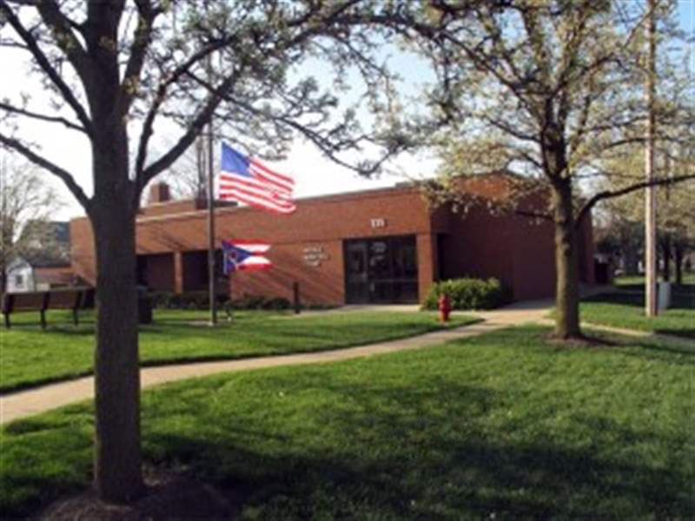

## MARCH 31, 2021

Medina City Council & Mayor

Medina County Commissioners

The following is the 2020 annual report of operations for the Medina Municipal Court as required by Ohio Revised Code Sec. 1901.14.

The Court received new filings of 10,185 cases and terminated 11,643 cases.

These cases generated $3,129,622.65in receipts, which included bond, criminal, traffic and civil judgments.

MEDINA MUNICIPAL COURT

COURT STAFF LISTINGS

|  |  |
| --- | --- |
| Judicial Staff | |
| Gary F. Werner | Judge, Administrative/Presiding |
| Linda Leggett | Chief Magistrate |
| Charles T. Lawrie | Magistrate |
|  |  |
| Administrative Staff |  |
| Cindy Lastuka | Court Manager |
| Katie Krosse | Administrative Assistant |
| Jon Mazanetz | Senior IT Technician |
| Shari McKee | Assignment Commissioner |
|  |  |
| Bailiffs |  |
| Carl Meding | Chief Bailiff |
| Bill Saus | Bailiff (retired as of October 1, 2020) |
| Patty Lavery | Bailiff |
| Dave Ellinger | Bailiff |
| Steve Wilmington | Bailiff |
| Ryan Nagy | Bailiff |
| Nathan Janus | Bailiff |
|  |  |
| Probation Department |  |
| Matt Esterle | Chief Probation Officer |
| Gene Merinar | Deputy Chief Probation Officer |
| Molly Kafer | Probation Officer |
| Angela Kiss | Probation Officer |
| Amy Darr | Probation Officer |
| Melanie Stroup | Probation Officer (P/T) |
| Noelle Hayes | Probation Officer/Support Staff (P/T) |
| Renee Thomas | Probation Secretary (P/T) |
|  |  |
|  |  |
|  |  |

MEDINA MUNICIPAL COURT

CLERK OF COURT STAFF LISTINGS

|  |  |
| --- | --- |
| Supervisory Staff |  |
| Joseph Salzgeber | Clerk of Court |
| Jacqueline Ols | Chief Deputy Clerk |
|  |  |
| Criminal Traffic |  |
|  |  |
| Cynthia Kolosky | Deputy Clerk |
| Nichole Galante | Deputy Clerk |
| Nikki Meyers | Deputy Clerk |
| Doris Sidwell | Deputy Clerk |
| Christine Green | Deputy Clerk |
| Peggy Natterer | Deputy Clerk (P/T) |
| Tracy Wasmer | Deputy Clerk (P/T) |
|  |  |
| Civil/Small Claims |  |
| Kate Cather | Deputy Clerk |
| Laura Riegelsberger | Deputy Clerk |
| Megan Pierce  Laureen Lewis | Deputy Clerk  Deputy Clerk |
| Michele Sloan | Deputy Clerk (P/T)/Bookkeeper |



CASE FILINGS AND TERMINATION STATISTICS

Cindy Lastuka, Court Manager

The following is a report of the Medina Municipal Court cases filed and terminated for each case type as established by the Ohio Supreme Court. The information provided is taken from the Administrative and Individual Judge Reports submitted monthly to the Ohio Supreme Court.



The following breaks down total traffic and criminal cases based upon the originating state, county, municipal, or township arresting agency.



The following breaks down total operating a vehicle while under the influence of alcohol or a drug of abuse (“OVI”) cases based upon the originating state, county, municipal, or township arresting agency.



|  |  |  |  |
| --- | --- | --- | --- |
| BRUNSWICK MAYOR'S COURT 2020 CASE FILINGS | | | |
| Type | # Filed | Transferred to Medina Municipal Court | Transfer % |
|
| Traffic | 1,764 | 80 | 4.54% |
| OVI | 78 | 11 | 14.10% |
| Criminal | 440 | 49 | 11.14% |
| Tax | 251 | 1 | 0.40% |
| Dog | 14 | 0 | 0.00% |

The Brunswick Mayor’s Court, which is within the Court’s jurisdiction, provided the information to the left for this 2020 Annual Report.

The following breaks down total “Other Traffic” cases based upon the originating state, county, municipal, or township arresting agency.



The following several pages graphically display caseloads by case type over the last five years, with trend lines superimposed to convey case filing trends. The total annual cases comparison is the last graph displayed.

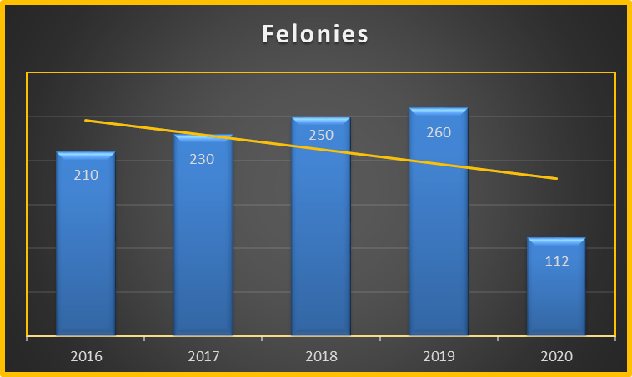

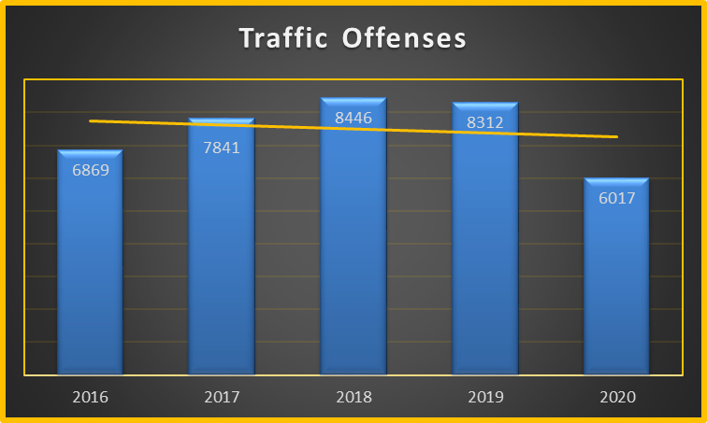

The following table stretches over several pages. It summarizes all receipts and disbursements, alphabetically arranged by recipient, which the Clerk’s office made during the referenced 12-month period in 2020.



|  |  |  |  |  |  |
| --- | --- | --- | --- | --- | --- |
| Traffic/Criminal Account Balance Listing | | | | | |
| For 01/01/2020 To 12/31/2020 | | | | | |
| Account | Beginning  Balance | Receipts | Agency  Checks | Checks | Ending  Balance |
|
| Disbursement | | | | | |
| AGENCYCHECK | (612.10) | 0.00 | 0.00 | 0.00 | (612.10) |
| BOND DEPOSIT | 150,980.93 | 205,444.15 | 0.00 | 234,574.15 | 121,850.93 |
| CRIMINAL EOM ADJUSTMENT | (43,999.02) | 0.00 | 0.00 | 0.00 | (43,999.02) |
| CRIMINAL REFUNDS | 0.00 | 2,679.05 | 0.00 | 2,056.40 | 622.65 |
| MIAMI CO SHERIFF FEES | 2.00 | (2.00) | 0.00 | 0.00 | 0.00 |
| RESTITUTION | 300.00 | 9,367.12 | 0.00 | 9,267.12 | 400.00 |
|  | 106,671.81 | 217,488.32 | 0.00 | 245,897.67 | 78,262.46 |
| BRUNSWICK HILLS FISCAL OFF | | | | | |
| BRUNS HILLS DUI ENFRCMENT ACCT | 75.00 | 951.00 | 1,001.00 | 0.00 | 25.00 |
|  | 75.00 | 951.00 | 1,001.00 | 0.00 | 25.00 |
| BRUNSWICK HILLS TOWNSHIP, ETAL | | | | | |
| BRUNS. HILLS TWP. POLICE FEES | 270.00 | 2,183.43 | 2,323.97 | 0.00 | 129.46 |
|  | 270.00 | 2,183.43 | 2,323.97 | 0.00 | 129.46 |
| CAPITAL RECOVERY | | | | | |
| CAPITAL RECOVERY COLLECTIONS | 4,129.50 | 47,915.15 | 50,271.60 | 0.00 | 1,773.05 |
|  | 4,129.50 | 47,915.15 | 50,271.60 | 0.00 | 1,773.05 |
| CLERK BRUNSWICK MAYORS COURT | | | | | |
| BRUNS CITY DUI ENFORCEMENT | 60.00 | 1,419.61 | 1,321.28 | 0.00 | 158.33 |
| BRUNSWICK CITY DRUG ENF. | 200.00 | 1,045.00 | 1,120.00 | 0.00 | 125.00 |
| BRUNSWICK CITY ORDINANCE FINES | 400.00 | 18,942.68 | 17,938.66 | 0.00 | 1,404.02 |
| BRUNSWICK MAYOR'S COURT COSTS | 307.00 | 4,848.00 | 4,787.00 | 0.00 | 368.00 |
|  | 967.00 | 26,255.29 | 25,166.94 | 0.00 | 2,055.35 |
| CLERK CHIPPEWA VILLAGE | | | | | |
| CHIPPEWA VILLAGE FINES | 0.00 | 300.00 | 300.00 | 0.00 | 0.00 |
| CUYAHOGA COUNTY SHERIFF | | | | | |
| CUYAHOGA COUNTY SHERIFF | 41.00 | 51.40 | 68.65 | 0.00 | 23.75 |
|  | 41.00 | 51.40 | 68.65 | 0.00 | 23.75 |
| HINCKLEY TOWNSHIP FISCAL OFFICER | | | | | |
| HINCKLEY TWP DUI ENFRCMNT ACCT | 124.91 | 432.98 | 531.56 | 0.00 | 26.33 |
| HINCKLEY TWP. DRUG ENFORC. | 50.00 | 675.00 | 675.00 | 0.00 | 50.00 |
| HINCKLEY TWP. POLICE FEES | 112.17 | 1,526.19 | 1,533.31 | 0.00 | 105.05 |
|  | 287.08 | 2,634.17 | 2,739.87 | 0.00 | 181.38 |
| MEDINA CITY FINANCE DIRECTOR | | | | | |
| BANK PROCESSING FEE | 16.00 | 96.00 | 112.00 | 0.00 | 0.00 |
| CASE MANAGEMENT FUND EXPENSE ACCOUNT | 3,102.34 | 34,948.90 | 35,254.79 | 0.00 | 2,796.45 |
| CLERKS COMPUTER IMPROVEMENT FU - CRIMINAL | 6,213.70 | 69,281.64 | 70,084.48 | 0.00 | 5,410.86 |









MAGISTRATES’ OFFICE 2020 REPORT

*LINDA A. LEGGETT* – Chief Magistrate

*CHARLES T. LAWRIE* – Magistrate

Chief Magistrate Leggett and Magistrate Lawrie are both active members of the Ohio Association of Magistrates.

JUDICIAL SEMINARS

(All seminars are through the Judicial College of the

Supreme Court of Ohio unless otherwise noted)

Magistrate Leggett attended the following seminar(s):

April 2020: Courts and Coronavirus Webinar:

*Tolling Issues for Municipal and County Courts*

April 2020: Courts and Coronavirus Webinar:

*Tolling Issues for Common Pleas and Municipal and County Courts Part 2*

May 2020: Courts and Coronavirus Webinar:

*Continuing Jury Operations (During a Pandemic)*

September 2020: Ohio Association of Magistrates 2020 Fall Conference:

*Ending the Cycle of Hope and Repression: Ballots and Bullets Black Power Politics and Urban Warfare in 1968 Cleveland; Civility & Respect in the Virtual Workplace; Supreme Court Update; Evidence and Social Media; Street Smart – Adult Drug Education; Judicial Wellness and Compassion Fatigue; A Potpourri of Topics ; Women’s Right to Vote in Ohio*

September 2020: Courts and Coronavirus Webinar:

*Evictions: Part III – The CDC Eviction Moratorium Order*

Magistrate Lawrie attended the following seminar(s):

April 2020: Courts and Coronavirus Webinar:

*Tolling Issues for Municipal and County Courts*

April 2020: Courts and Coronavirus:

*Tolling Issues for Common Pleas and Municipal and County Courts Part 2*

PROBATION DEPARTMENT 2020 REPORT

*Matt Esterle* - Chief Probation Officer

*Gene Merinar* - Deputy Chief Probation Officer

*Amy Darr* - Probation Officer/Grant Coordinator

*Noelle Hayes* - Probation Officer/Sealing of Records

*Angela Kiss* - ISP Probation Officer

*Molly Kafer* - Probation Officer

*Melanie Stroup* - Probation Officer/Community Service Coordinator

*Renee Thomas* - Lead Administrative Assistant

The year 2020 proved to be a year of challenges and accomplishments in the Adult Probation Department. Starting in early 2020, the COVID-19 crisis/pandemic altered the course of business dramatically with closures and shut-downs, stay at home orders, mask mandates, etc. The Court and more specifically the Probation Department were not immune to this and changes in normal procedures and protocol were initiated.

The Probation Department obtained a $28,614.91 grant from the Ohio Supreme Court in 2020. This Remote Technology Grant was used to purchase seven (7) laptop computers as well as a new case-management tool, Ohio Community Supervision System (OCSS). These technological improvements made possible by the grant allowed the department to continue working with, supervising, and monitoring probationers without physically reporting on premises to their assigned officer. Supervision appointments, Interviews, Compliance Verification were all handled virtually ensuring defendants are still being held accountable, serving their sentences, and completing court ordered directives all while maintaining safe distancing and decreasing foot traffic in and about the court. This action has reduced potential exposure to coronavirus increasing staff safety and decreasing community spread. Additionally, the OCSS System enables text notification and alerts to notify probationers or their scheduled appointments, drug testing requirements and communication with their assigned officer. Early indicators show a marked increase in compliance to court orders, reporting requirements, and satisfying sentencing directives.

In 2020, the Probation Department completed 751 Pre-Sentence Investigations (PSI) for the court including 192 defendants incarcerated in the Medina County Jail. A Pre-Sentence Investigation is a report prepared by a court's probation officer on request by the court. It is the report of the investigation conducted to find out the history including the educational, criminal, family, and social background of a person convicted of a crime. It summarizes for a court the background information needed to determine the appropriate sentence.

The Probation Department completed 142 Sealing of Records investigations for applicants seeking relief and sealing of prior records. Record sealing is the practice of sealing or, in some cases, destroying court records that would otherwise be publicly accessible as [public records](https://en.wikipedia.org/wiki/Public_record). The term is derived from the tradition of placing a [seal](https://en.wikipedia.org/wiki/Seal_(device)) on specified files or documents that prevents anyone from reviewing the files without receiving a [court order](https://en.wikipedia.org/wiki/Court_order). The modern process and requirements to seal a record and the protections it provides vary from jurisdiction to jurisdiction, and even between civil and [criminal](https://en.wikipedia.org/wiki/Criminal_law) cases. Generally, record sealing can be defined as the process of removing from general review the records pertaining to a court case. However, the records may not completely disappear and may still be reviewed under limited circumstances; in most instances, it requires a court order to unseal records once they are sealed. In the United States, some states order records to be destroyed after they are sealed.

Once a record is sealed, in some states, the contents are legally considered never to have occurred and are not acknowledged by the state. The public policy of record sealing balances the desire to free named citizens from the burdens caused by the information contained in state records while maintaining the state's interest in the preservation of records that may be beneficial to the state or other citizens. In many cases, a person with a sealed record gains the legal right to deny or not acknowledge anything to do with the arrest and the legal proceedings from the case itself.

The constitutional amendment known as “Marsy's Law” became effective on February 5, 2018, and expanded the rights afforded to victims of crimes. (Ohio Constitution, Article I, Section 10a.) Among the rights Marsy’s Law secures are a victim’s right to request notice of any court proceeding involving the crime and to speak at those proceedings. All 50 states allow victim impact statements at some phase of the sentencing process. Most states permit them at sentencing hearings and victim impact information is generally included in the pre-sentencing report presented to the judge.

Victim impact statements are written or oral information from crime victims, in their own words, about how a crime has affected them. The purpose of victim impact statements is to allow crime victims, during the decision-making process on sentencing, to describe to the court the impact of the crime. Victim impact statements may provide information about damage to victims that would otherwise have been unavailable to courts. Victim impact statements may include descriptions of:

* + Physical damage caused by the crime.
  + Emotional damage caused by the crime.
  + Financial costs to the victim from the crime.
  + Medical or psychological treatments required by the victim or his or her family.
  + The need for restitution (court-ordered funds that the offender pays the victim for crime-related expenses).
  + The victim's views on the crime or the offender.
  + The victim's views on an appropriate sentence.

A judge may use information from these statements to help determine an offender's sentence. Many victims report that making such statements improves their satisfaction with the criminal justice process and helps them recover from the crime. The probation department processed 285 victim impact statements during 2020.

The Court placed 242 offenders on probation during 2020. Of these, 49% were convicted of OVI or closely related offenses, 22% were convicted of Domestic Violence/Threatening Domestic Violence, 6% were convicted of property offenses, 5% of other violent offenses (assault), and the remaining 18% were convicted of various offenses including but not limited to drug law violations, sex offenses and other traffic offenses. Reporting appointments for the year totaled 1,161 and for the 4th straight year, over 1,000 drug and alcohol screens were submitted. The probation department also supervised individuals ordered to pre-trial bond reporting and electronically monitored house arrest and transdermal alcohol monitoring.

In 2020, the Medina Municipal Court monitored 86 clients on a Continuous Alcohol Monitoring Device (CAM) for a total of 5,257 days of monitoring. There were 11 confirmed alcohol consumption violations and 13 instances of tampering with the monitoring equipment. The MMC Probation Department reached a 99.6% “Sober Days” rating, meaning of the 5,257 days’ clients were monitored, 99.6% of them were quantifiably abstinent. Nationally, in 2020, the average was 98.7%. Clients in the CAM Program participated for an average of 61 days.

In 2020, MMC clients were monitored with Global Positioning (GPS) for a total of 794 days.

Defendants completed 1,818 Hours of Community Service Work during the year. The projects worked on benefited the citizens of this jurisdiction and represented a savings of approximately $18,180.00 to taxpayers.

Goals for the Probation Department in 2021 include: (i) establishing a Veterans Treatment Court specialized docket to assist and address justice involved veterans; (ii) increasing success rates of individuals placed on probation; (iii) reducing jail overcrowding; (iv) increasing access to support systems and substance abuse treatment programming including medication assisted therapy (“MAT”) by working with local treatment providers; and (v) implementing a Community Supervision Unit wherein probation officers will be conducting home visits and meeting defendants in the community to verify and support adherence to sentencing directives. These are just some of the exciting changes occurring within this department and the court in general.

BAILIFF'S 2020 OFFICE REPORT

*Carl Meding* - Chief Bailiff

*Patty Lavery* - Deputy Bailiff

*Bill Saus* – Deputy Bailiff (retired as of 10/1/2020)

*Dave Ellinger* – Deputy Bailiff

*Steve Wilmington* – Deputy Bailiff

*Ryan Nagy* – Deputy Bailiff

*Nathan Janus* – Deputy Bailiff

Current staffing of the Court's Bailiff's Office consists of the Chief Bailiff and five full-time Deputy Bailiffs. Bailiffs remain responsible for courtroom and general building security, attending to the Court's audio recording system, assisting the Clerk of Court's operation by way of in court operation of the Benchmark Case Management System, and assisting the Court's Probation department by conducting field visits. The Chief Bailiff also supervises four additional part-time security guards who operate the Court's metal detector at the Court's security checkpoint.

In regard to the court security function, the Bailiff's Office handled twelve (12) extraordinary incidents in the Court. A synopsis of these incidents is listed in the accompanying attachment.

One Deputy Bailiff is responsible for the service of subpoenas and other court documents throughout the Court's jurisdiction. This includes executing evictions and Court ordered recovery/sales of property. During 2020, the Bailiff's Office scheduled and executed 73 Writs of Execution (eviction orders), a 48.2% decrease when compared to 2019 activity. (See Table #1) Also, one (1) Replevin action and three (3) Court ordered auctions were conducted during 2020.

The Bailiff's Office continues to pursue defendants who have failed to appear at the Court, or otherwise ignored court orders. During 2020 the Court's Bailiffs physically arrested 11 defendants, and cleared a total of 251 warrants by all means. This compares to the 16 defendants arrested, and 217 total warrants cleared in 2019 by the Bailiff's Office. This is an increase of 15.7% in the total number of warrants cleared when compared to the preceding year

It should be noted that the number of evictions executed, as well as the pro-active warrant service activity, were all significantly impacted by the COVID-19 pandemic. All normal Court activity was hampered by the necessity of adhering to state and local guidelines which effected the ability of the Bailiff's Office to go into the community and conduct normal operations. For example, the various Federal moratoriums on evictions forestalled a number of evictions that would have normally been carried out. Likewise, restrictions put in place at the Medina County Jail severely limited the number of defendants that could be accepted into the facility, thus necessarily curtailing the pro-active attempts to locate and arrest individuals with active warrants. Overall, this was offset to some degree by increasing telephone contacts with these individuals, and convincing them to voluntarily come to the Court to resolve their warrant issues without the specter of jail incarceration being likely.

The monitoring of defendants not in custody, and under Court issued conditions of bond remains an important function of the Bailiff's Office. The Bailiff's Office enters those defendants into the NCIC/LEADS Supervised Release File. Doing so allows law enforcement to be aware of the status of these defendants should they have contact with them. This allows the Court to assist the county jail in reducing the jail population which is a critical need during the ongoing COVID-19 pandemic. This in turn allows the release of more low risk defendants, and yet maintain some pre-adjudication control of these defendants by way of imposing certain conditions of bond which are fashioned to encourage compliance.

During 2020 the Bailiff's Office entered 198 defendants into the NCIC/LEADS Supervised Release File (with an additional 84 defendants already previously entered and active at the beginning of 2020). These entries produced 68 subsequent contacts with law enforcement agencies for a variety of reasons. Additionally, the Bailiff's Office conducted 215 random compliance checks in regard to these entered defendants. This was a 45.3% increase in the number of random compliance checks when compared to the 148 checks conducted during 2019. Defendants were found at home during 86 of these random compliance checks, during which 30 violations were discovered. The remaining 56 visits found the defendants in compliance with their conditions of bond. When combining the 68 law enforcement contact violations, and the 30 violations discovered by the Bailiff's Office, there were a total 98 violations recorded in relation to the 282 total defendant's entered in the Supervised Release File during 2020. This represents a 35.0% bond condition violation rate. Additionally the Court issued 29 warrants for defendants who failed to appear for their court hearings.

The Court's Bailiff's Office also enters convicted defendants who are on probation with the Court into the NCIC/LEADS Supervised Release File. These entries allow law enforcement agencies across the nation to identify people they have come into contact with who are on probation with the Court. These agencies may then contact the Court's Probation Department for additional information as necessary, (e.g. individuals being screened by ICE, or individuals being screened for a firearm purchase). This ultimately allows the Court's Probation department to better monitor those probationers.

At the end of 2020, the Court listed 242 probationers in the Supervised Release File. During 2020 the Court received 59 notifications ("hits") relating to probationer's contacts with law enforcement. These contacts range from minor traffic violations, to more serious misdemeanor offences such as OVI, DOMESTIC VIOLENCE and VIOLATING PROTECTION ORDERS, as well as felony violations including FELONIOUS ASSAULT, AGGRAVATED DRUG POSSESSION and VANDALISM. Furthermore the Bailiff's Office also assists the Probation department by conducting visits to probationer's residences at the request of their respective probation officers. These visits are performed in an effort to monitor the probationer and insure compliance with their conditions of probation. During 2020 the Bailiff's Office conducted 99 such visits (compared with 89 such visits in 2019). These visits resulted in seven (7) violations being found, and 31 visits where no violations were discovered. The remainder of the visits (61) found the probationer not at home at the time of the visit.

Bailiff Carl F. Meding

8 January 2021

2020 SECURITY INCIDENT SYNOPSIS

1-10-20

A set of "brass knuckles" were found near the employee entrance to the Court.

1-22-20

Medical emergency in Magistrate's courtroom. Defendant had "anxiety attack" and began vomiting. Courtroom was closed for approximately 40 minutes to allow cleaning and sanitizing.

2-19-20

Deputy Bailiff executing Writ of Restitution in Brunswick discovered defendant had committed suicide in the residence.

2-27-20

Medical situation involving arrest. Probationer arrived for probation appointment highly intoxicated (.36% BAC). Probationer taken into custody and taken to hospital for medical clearance due to County Jail refusing to accept subject who was so highly intoxicated. Bailiff escorted defendant in ambulance to hospital ER.

6-19-20

Defendant fled Court prior to hearing. Bailiffs attempted to stop defendant as he drove out of Court parking lot. One Deputy Bailiff knocked off balance and fell. Defendant subsequently charged with additional offence.

7-6-20

Defendant checking in for court hearing was found to be in possession of medically prescribed marijuana. Defendant was prohibited from bringing marijuana into the Court building.

9-28-20

Medical emergency. Prisoner being brought to Court began feeling faint and dizzy. Prisoner was assisted to ground as she started to fall. LST was summoned and checked on prisoner.

10-22-20

Defendant sentenced to jail term. Defendant became agitated while awaiting transport to jail. After being held in contempt, prisoner attacked Court Bailiffs and a probation officer. Prisoner resisted attempts to remove her from courtroom. One Bailiff was spit on, and another bailiff was "clawed" by defendant as she had to physically carried out of the Court building to jail transport vehicle.

11-9-20

Medical emergency. Defendant in courtroom awaiting hearing, began to display overdose/withdrawal symptoms. LST was summoned and transported defendant to hospital ER.

11-10-20

Mother of defendant became highly emotional and agitated after son's court hearing. Female verbally accosted defense counsel in lobby causing a loud disturbance. Female was escorted from Court and she remained pacing in parking lot well after son was transported to County Jail. Bailiffs monitored defendant till she subsequently left the parking after approximately 2 hours.

12-11-20

Subject became verbally abusive to Court deputy clerk while paying fine. Subject disrupted Court operations with loud and profane language. Chief Probation officer and Deputy Bailiff instructed the subject to leave. Subject made contact with Security Guard and refused to leave. Subject was detained and MPD summoned. Subject subsequently cited for Trespass and Disorderly Conduct.

12-16-20

Medical emergency. Defendant in front of Magistrate for arraignment began experiencing fainting symptoms (possible anxiety attack). Bailiffs placed defendant in wheel chair and LST was summoned to assist the defendant.

TABLE #1

EVICTION ACTIVITY

(FORCIBLE ENTRY AND LOCK CHANGE)

YEAR NUMBER OF EVICTIONS

2016…………………………………155

2017…………………………………132

2018…………………………………113

2019……….………………………..141

2020…………….……….……………73

TABLE #2

WARRANT ENFORCEMENT ACTIVITY

TOTAL NUMBER OF WARRANTS RESOLVED……………………………………..…251

TOTAL NUMBER OF DEFENDANTS………………………………………………………241

WARRANTS RESOLVED BY ACTION TAKEN:

EXECUTED BY ARREST………………………………………………………….…………….11

CAME TO COURT AFTER HOME VISIT……………………………………………….…..5

CAME TO COURT AFTER PHONE CONTACT………………………………………...176

CAME TO COURT AFTER WARRANT BLOCK………………..…………………….….59

NUMBER OF HOME VISITS MADE…………………………………………………….….28

COMPUTER DEVELOPMENTS

2020 Annual Report

*Jon Mazanetz*

Senior IT Technician

The court employs a Management Information Specialist to coordinate all technology applications. The current equipment in place consists of 38 printers, 3 printer/copier/fax systems, 48 desktop workstations, 2 laptops.

The Medina Municipal Court received a Technology grant of $63,000 to install three Scale Computing servers which have replaced the two Dell Power Edge VRTX servers. These servers handle the case management system, segmented network storage, and online court access. The existing Dell server is now functioning as a backup of courthouse operations. A Meraki firewall appliance is installed to comply with requirements from the Ohio Leads Organization. For virus protection the court has Trend Micro running on all systems. Three Meraki access points are installed to allow employee and visitor access to the internet.

The court continues to work with Technology Engineering Group for guidance in hardware and software programs. They continue to be a highly valued asset to the courthouse for high level troubleshooting, maintenance, and implementation.

The court utilizes a case management system called Benchmark by Pioneer Technology Group of Sanford, Florida. The IT admin is heavily involved in the operation of the Benchmark software. The courthouse is looking to expand upon this software to add an E-Filing module as well as text notifications. This should provide more convenience as well as consistent reminders for scheduled appearances.

The court records are backed up to an Acronis cloud storage backup as well as local on our repurposed Dell VRTX servers. Audio is recorded in both courtrooms by software from FTR systems and is stored on the network drives. This audio dates to 2003 and is also backed up to the Acronis backup system. This year, the courthouse has implemented the process of Zoom hearings in response to the COVID-19 pandemic. Through additional grant funding, the courthouse will be implementing new A/V equipment in both the main courtroom and the Magistrate’s courtroom. The upgrades will provide a more modern workspace in the growing sector of remote hearings and meetings.

The technical staff attends various meetings each year to keep current on changes to the case management system as well as new trends in hardware and software development.

There are two LEADS systems in use by the court allowing authorized users to look up data for court processing. This also reduces the workload for Medina Police Department. The system is secured by a Meraki firewall. The website is hosted by Blue Domino. The site has the functionality to allow lookups based on case scheduling for criminal, traffic, and civil cases.

FOREIGN LANGUAGE INTERPRETING SERVICES

The Court maintains interpreting services for defendants who do not speak English and require assistance in their native language to understand court proceedings. The Supreme Court of Ohio contracts with Language Line Services of Monterey, California and offers their services to Ohio Courts to provide language translation for short court proceedings (approximately 5 to 10 minutes in length). Monarca Language Services, a Medina business, is used by the Court for other translation services.

WEDDINGS

Judge Werner performed 36 weddings in 2020.

Respectfully submitted:

MEDINA MUNICIPAL COURT

MARCH 31, 2021

Gary F. Werner Joseph Salzgeber

_________________________________ __________________________

GARY F. WERNER, JUDGE Clerk of Courts