

MEDINA MUNICIPAL COURT

2022 ANNUAL REPORT

GARY F. WERNER

presiding Judge &

administrative judge

joseph f. salzgeber

CLERK of Courts

135 North Elmwood Avenue

Medina, Ohio 44256

*Proudly serving the communities of Brunswick Hills Township, Brunswick City, Chatham Township, Chippewa Lake Village, Granger Township, Hinckley Township, Lafayette Township, Litchfield Township, Liverpool Township, Medina City, Medina Township, Montville Township, Spencer Township, Spencer Village, York Township, in addition to the Cleveland Metropolitan Park District, Medina County Sheriff and the Ohio State Patrol*

TABLE OF CONTENTS

|  |  |
| --- | --- |
| Subject | Page |
| Medina Municipal Court | 3 |
| Judicial Staff Listing | 4 |
| Clerk of Court Staff Listing | 5 |
| Case Filings and Terminations Statistics | 6 |
| Case Load Comparison by Arresting Agencies Total Traffic/Criminal | 7 |
| Case Load Comparison by Arresting Agencies OVI | 8 |
| Brunswick Mayor’s Court | 8 |
| Case Load Comparison by Arresting Agencies Other Traffic Offenses | 9 |
| Five Year Case Comparison Chart – Personal Injury and Civil Contracts | 10 |
| Five Year Case Comparison Chart – F.E.D., Other Civil, and Small Claims | 11 |
| Five Year Case Comparison Chart – Traffic Offenses Misdemeanors, and O.V.I. | 12 |
| Five Year Case Comparison Chart – Felonies and Total Cases | 13 |
| Clerk of Court Statement of Receipts and Disbursements | 14 |
| Magistrate’s Office 2022 Report | 20 |
| Probation Department 2022 Report | 21 |
| Veteran’s Treatment Court | 23 |
| Bailiff’s Office 2022 Report | 24 |
| Computer Developments 2022 Report | 27 |
| Foreign Language Interpreting Services & Weddings | 28 |

## C:\Users\clastuka\AppData\Local\Microsoft\Windows\INetCache\Content.Outlook\2J8JZIQV\square building.png

## MARCH 31, 2023

Medina City Council & Mayor

Medina County Commissioners

The following is the 2022 annual report of operations for the Medina Municipal Court as required by Ohio Revised Code Sec. 1901.14.

The Court received new filings of 10,905 cases and terminated 11,703 cases.

These cases generated $4,123,215.44in receipts, which included bond, criminal, traffic and civil judgments.

MEDINA MUNICIPAL COURT

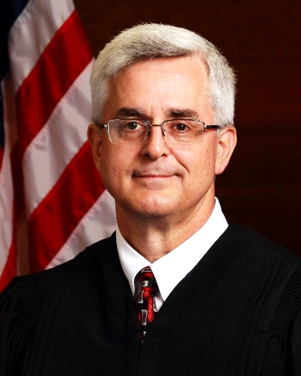COURT STAFF LISTINGS

|  |  |
| --- | --- |
| Judicial Staff | |
| Gary F. Werner | Judge, Administrative/Presiding |
| Linda Leggett | Chief Magistrate |
| Charles T. Lawrie | Magistrate |
|  |  |
| Administrative Staff |  |
| Cindy Lastuka | Court Manager |
| Jacki Ols | Administrative Assistant |
| Josh Strong | Senior IT Technician |
| Shari McKee | Assignment Commissioner |
|  |  |
| Bailiffs |  |
| Ryan Nagy | Chief Bailiff |
| Patty Lavery | Bailiff |
| Dave Ellinger | Bailiff |
| Nathan Janus | Bailiff |
| Steve McBride | Bailiff |
| Bob Gabriel | Bailiff |
| Ray Bulka | Bailiff |
|  |  |
| Probation Department |  |
| Matt Esterle | Chief Probation Officer |
| Gene Merinar | Deputy Chief Probation Officer |
| Angela Kiss | Probation Officer |
| Amy Darr | Probation Officer |
| Melanie Stroup | Probation Officer (P/T) |
| Noelle Hayes | Probation Officer (P/T) |
| Renee Thomas | Probation Secretary (P/T) |
|  |  |
|  |  |
|  |  |
|  |  |

MEDINA MUNICIPAL COURT

CLERK OF COURT STAFF LISTINGS

|  |  |
| --- | --- |
| Supervisory Staff |  |
| Joseph Salzgeber | Clerk of Court |
| Michele Sloan | Chief Deputy Clerk |
|  |  |
| Criminal Traffic |  |
|  |  |
| Doris Sidwell | Deputy Clerk |
| Jenny Prechtel | Deputy Clerk |
| Heather Silbaugh | Deputy Clerk |
| Tracy Wasmer | Deputy Clerk |
|  |  |
|  |  |
|  |  |
|  |  |
| Civil/Small Claims |  |
| Kate Cather | Deputy Clerk |
| Laura Riegelsberger | Deputy Clerk |
| Maggie Sonntag  Katie Masters | Deputy Clerk  Deputy Clerk |
|  |  |

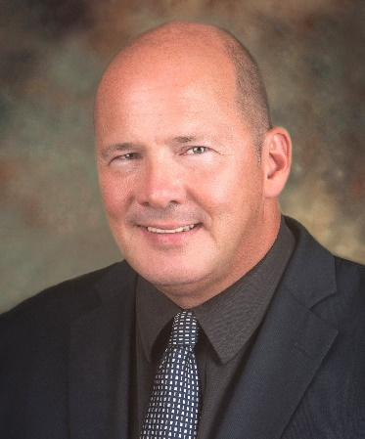

CASE FILINGS AND TERMINATION STATISTICS

Cindy Lastuka, Court Manager

The following is a report of the Medina Municipal Court cases filed and terminated for each case type as established by the Ohio Supreme Court. The information provided is taken from the Administrative and Individual Judge Reports submitted monthly to the Ohio Supreme Court.



The following breaks down total traffic and criminal cases based upon the originating state, county, municipal, or township arresting agency.



The following breaks down total operating a vehicle while under the influence of alcohol or a drug of abuse (“OVI”) cases based upon the originating state, county, municipal, or township arresting agency.



The Brunswick Mayor’s Court, which is within the Court’s jurisdiction, provided the information

for this 2022 Annual Report.

|  |  |  |  |
| --- | --- | --- | --- |
| CASES TYPE | CASES FILED | CASES TRANSFERRED TO | Transfer |
|  |  | MEDINA MUNICIPAL COURT | % |
|  |  |  |  |
| Traffic | 2,099 | 74 | 3.53% |
| OVI | 73 | 15 | 20.55% |
| Criminal | 424 | 54 | 12.74% |
| Tax | 641 | 3 | 0.47% |
| Dog | 16 | 1 | 6.25% |
| Building | 7 | 0 | 0.00% |

The following breaks down total “Other Traffic” cases based upon the originating state, county, municipal, or township arresting agency.



The following several pages graphically display caseloads by case type over the last five years, with trend lines superimposed to convey case filing trends. The total annual cases comparison is the last graph displayed.

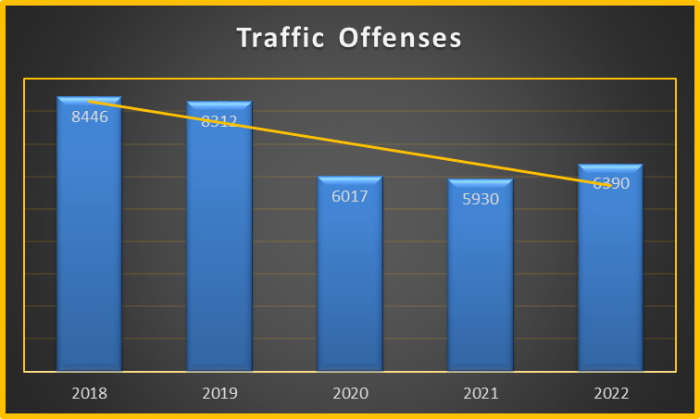

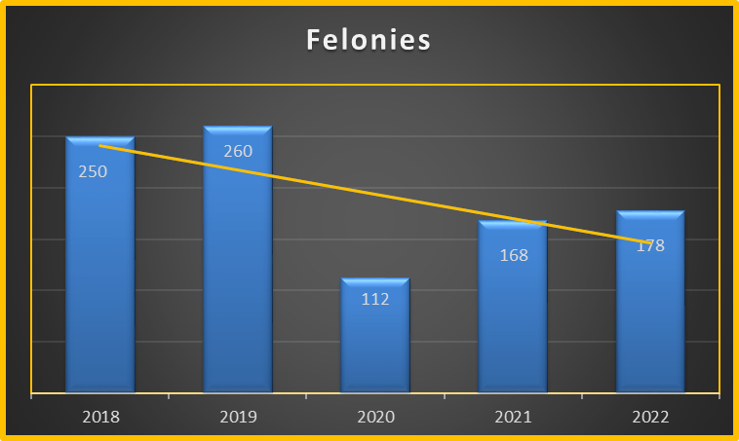

The following table stretches over several pages. It summarizes all receipts and disbursements, alphabetically arranged by recipient, which the Clerk’s office made during the referenced 12-month period in 2022.







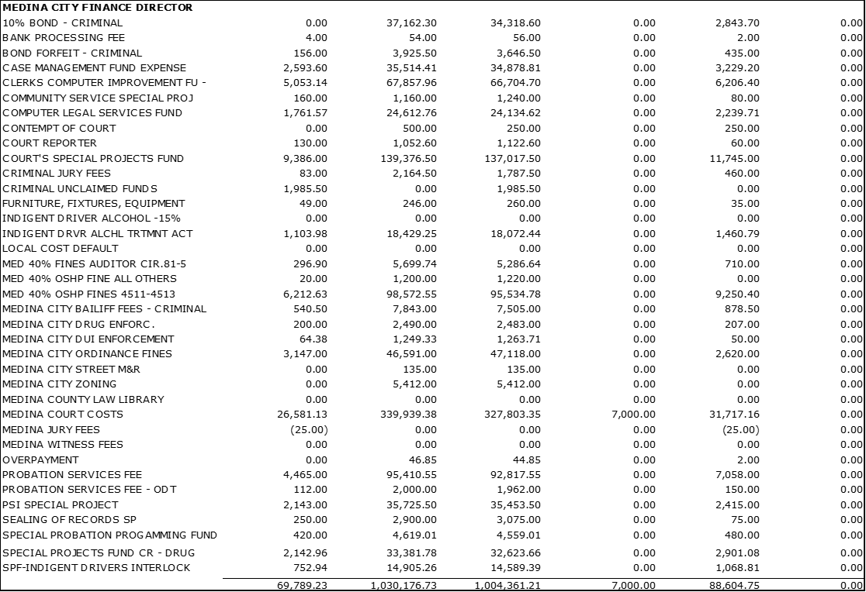













MAGISTRATES’ OFFICE 2022 REPORT

*LINDA A. LEGGETT* – CHIEF MAGISTRATE

*CHARLES T. LAWRIE* – MAGISTRATE

Chief Magistrate Leggett and Magistrate Lawrie are both active members of the Ohio Association of Magistrates.

JUDICIAL MENTOR PROGRAM

In 2022, Magistrate Leggett participated in the Supreme Court of Ohio Judicial College Mentor Program. She volunteered to mentor a newly appointed Akron Municipal Court Magistrate. All new magistrates must participate in the one-year mentoring program to elevate the competence, collegiality and success of Ohio’s judiciary. The mentor’s responsibility is to provide information, assistance and encouragement to the new magistrate during the first year on the bench. The program consists of at least four quarterly contacts over the course of a twelve-month period. Areas of discussion during the mentor/mentee contact include transitioning to the bench; professional conduct, judicial philosophy and personal development; relationship building and community involvement; and court operations and case flow management. The mentor and new magistrate complete an Individualized Mentoring Plan within sixty days of the mentor assignment and a Confirmation of Completion Statement upon the completion of the twelve-month program.

JUDICIAL SEMINARS

(All seminars are through the Judicial College of the

Supreme Court of Ohio unless otherwise noted)

Magistrate Leggett attended the following seminar(s):

March 31, 2022: The Supreme Court of Ohio – Language Services Section

*Appointment of Court Interpreters under Rules of Superintendence 88 & 89 for the Courts of Ohio.*

September 7 – 9, 2022: Ohio Association of Magistrate’s 2022 Fall Conference

*Report on the Judiciary; Don’t Stop Thinking About Tomorrow: iCourt Task Force Findings and Recommendation; The Weaponization of Technology; E-Discovery: How to Manage Discovery of Electronically Stored Information; Cryptocurrency Primer; eWarrants: How to Use the Cutting-Edge Technology; Credit Card Cases; Consumer Sales Practices Act; Driving Under Suspension and Other BMV Issues; Probably Cause in Traffic Stops; You Do What? The Work of Magistrates in Various Practice Areas and the Challenges They Face; You Posted What? Due Process in the Era of #MeToo and TikTok.*

Magistrate Lawrie attended the following seminar(s):

May 4 – 6, 2022: Ohio Association of Magistrate’s 2022 Spring Conference

*Confronting Racial Inequality in the Justice System; LGBTQ+: Shaping an Inclusive Judicial System; Immigration Issues in Ohio Courts; Tame the Digital Chaos – Time, Task, Email and Distraction Management; Supreme Court of Ohio Writing Manual – Refresher & Common Mistakes; Judicial Writing – Perspectives from the Trial and Appellee Courts; Landlord Tenant Law (Plaintiff’s Perspective); Landlord Tenant Law (Defendant’s Perspective); Deal or No Deal – Ethics on Trial – Part I ; Ethical Tips from Hollywood Movies – Part II.*

PROBATION DEPARTMENT 2022 ANNUAL REPORT

Matt Esterle-Chief Probation Officer/Valor Court Program Coordinator

Gene Merinar-Deputy Chief Probation Officer

Amy Darr-Probation Officer/JRIG/CCA Grant Coordinator

Robert Gabriel-Bailiff/Hybrid Probation/Community Service

Noelle Hayes-ISP Probation Officer/Sealing of Records

Angela Kiss-Valor Court Probation Officer

Melanie Stroup-Probation Officer

Renee Thomas-Department Secretary

In 2022, the probation department completed 591 Pre-Sentence Investigations (PSI) for the court including 120 defendants incarcerated in the Medina County Jail. A Pre-Sentence Investigation is a report prepared by a court's probation officer on request by the court. It is the report of the investigation conducted to find out the history including the educational, criminal, family, and social background of a person convicted of a crime. It summarizes for a court the background information needed to determine the appropriate sentence.

The probation department completed 82 Sealing of Records investigations for applicants seeking relief and sealing of prior records. Record sealing is the practice of sealing or, in some cases, destroying court records that would otherwise be publicly accessible as [public records](https://en.wikipedia.org/wiki/Public_record). The term is derived from the tradition of placing a [seal](https://en.wikipedia.org/wiki/Seal_(device)) on specified files or documents that prevents anyone from reviewing the files without receiving a [court order](https://en.wikipedia.org/wiki/Court_order). The modern process and requirements to seal a record and the protections it provides vary from jurisdiction to jurisdiction, and even between civil and [criminal](https://en.wikipedia.org/wiki/Criminal_law) cases.

Generally, record sealing can be defined as the process of removing from general review the records pertaining to a court case. However, the records may not completely disappear and may still be reviewed under limited circumstances. In most instances, it requires a court order to unseal records once they are sealed. In the United States, some states order records to be destroyed after they are sealed.

Once a record is sealed, in some states, the contents are legally considered never to have occurred and are not acknowledged by the state. The public policy of record sealing balances the desire to free named citizens from the burdens caused by the information contained in state records while maintaining the state's interest in the preservation of records that may be beneficial to the state or other citizens. In many cases, a person with a sealed record gains the legal right to deny or not acknowledge anything to do with the arrest and the legal proceedings from the case itself.

Victim impact statements are written or oral information from crime victims, in their own words, about how a crime has affected them. All 50 states allow victim impact statements at some phase of the sentencing process. Most states permit them at sentencing hearings and victim impact information is generally included in the pre-sentencing report presented to the judge. The probation department processed 157 victim impact statements during 2022.

The purpose of victim impact statements is to allow crime victims, during the decision-making process on sentencing, to describe to the court the impact of the crime. A judge may use information from these statements to help determine an offender's sentence. Victim impact statements may provide information about damage to victims that would otherwise have been unavailable to courts. Victims are often not called to testify in court, and if they testify, they must respond to narrow, specific questions. Victim impact statements are often the victims' only opportunity to participate in the criminal justice process or to confront the offenders who have harmed them. Many victims report that making such statements improves their satisfaction with the criminal justice process and helps them recover from the crime.

Victim impact statements may include descriptions of:

* + Physical damage caused by the crime.
  + Emotional damage caused by the crime.
  + Financial costs to the victim from the crime.
  + Medical or psychological treatments required by the victim or his or her family.
  + The need for restitution (court-ordered funds that the offender pays the victim for crime-related expenses).
  + The victim's views on the crime or the offender.
  + The victim's views on an appropriate sentence.

On January 1, 2022, the Department’s adult probation population was 256 individuals under court-ordered supervision. A total of 254 individuals were discharged from probation in 2022, 92% of which discharged individuals were considered successful releases. During 2022, 326 offenders were referred to the probation department for placement on supervision and community service orders. Of these, 51% were convicted of OVI or closely related offenses; 7% were convicted of Domestic Violence/Threatening Domestic Violence; 2% were convicted of property offenses; 8% were other violent offenses (assault); and the remaining 32% were convicted of various offenses including but not limited to drug law violations, sex offenses, and other traffic offenses. Reporting appointments for the year totaled 1,449 total contacts and over 740 drug and alcohol screens were submitted. The probation department also supervised individuals ordered to pre-trial bond reporting and electronically monitored house arrest and transdermal alcohol monitoring.

In 2022, the Medina Municipal Court monitored 60 clients on a Continuous Alcohol Monitoring Device (CAM) for a total of 3,869 days of monitoring. There were 5 confirmed alcohol consumption violations and 9 instances of tampering with the monitoring equipment. The MMC Probation Department reached a 99.7% “Sober Days” rating, meaning of the 3,869 days’ clients were monitored, 99.7% of them were quantifiably abstinent. Nationally, in 2021, the average was 98.9%. Clients in the CAM Program participated for an average of 100 days.

In 2022, 6 MMC clients were monitored with Global Positioning (GPS) for a total of 359 days.

In 2022, 1,132 Hours of Community Service Work was completed during the year on projects benefitting the citizens of this jurisdiction and representing a savings of approximately $11,320.00 USD to taxpayers.

Goals for the probation department in 2023 include; expanding access to the Veterans Treatment Court specialized docket to assist and address justice involved veterans. Increasing success rates of individuals placed on probation while reducing jail overcrowding and increasing access to support systems and substance abuse treatment programming including medication assisted therapy (MAT) by working with local treatment providers.

Veterans Treatment Court

In 2021, the Honorable Gary F. Werner, Judge of the Medina Municipal Court, established the State of Ohio’s 29th Veterans Treatment Court Program, otherwise known as Valor Court. Veteran’s Treatment Courts are specialized dockets dedicated to defendants with military experience who find themselves in the criminal justice system. It was established recognizing that many of our veterans return to civilian life with serious physical, substance abuse disorders, and/or mental trauma. Too often, these conditions lead to their involvement with the criminal justice system.

Valor Court provides an evidenced-based alternative to traditional sentencing methods, using a non-adversarial approach to addressing criminal offenses. It is structured to assist the veteran with access to programs, treatment and interaction with mentors, in a collaborative initiative to enhance their chances of sustained success. Its rewards and sanctions are designed to incentivize rehabilitation, to anticipate and deter relapse, and to restore participants to functional decision making and relationships.

Valor Court is supervised by an Advisory Committee of community stakeholders and is operated by volunteers from the court, relevant government agencies, and the community. Prior to implementing the program, and to ensure effective operation of the program, the court, its staff, and various community treatment providers attended various training courses. The courses included 3-days of intensive in-person training, as well as over 25-hours of virtual training. The training was provided by the United States Department of Justice / Office of Justice Programs, in collaboration with the Justice for Vets/National Association of Drug Court Professionals.

Judge Gary F. Werner and the Valor Court received preliminary certification from the Supreme Court of Ohio in August 2021 granting permission to begin operations. In December 2021, Supreme Court Staff attended/observed and evaluated the Valor Court Program. Certification is granted when the written materials submitted by each court and observations made during the site review demonstrate compliance with the certification standards under Ohio Supreme Court’s Rules of Superintendence, Rules 36.20 through 36.26.

Valor Court received Final Certification December 16th, 2021. To date: Thirteen (13) individuals have elected to participate in Valor Court since program inception. Two (2) Vets completed their placements and period of supervision in 2022 earning successful releases. Valor Court received grant funding ($150,000.00) from the Ohio Department of Mental Health & Addiction Services (OMHAS) to be used for the operation of the Valor Court Program through fiscal year 2023. The Valor Court Program also received an ATP (Addiction Treatment Programming) Grant in the amount $44,500.00 from the Medina County Alcohol, Drug Addiction & Mental Health Board and Ohio Department of Mental Health and Addiction Services Department (OMHAS). The OMHAS Grant is earmarked to expand and offer resources to veterans who are otherwise not eligible to receive Department of Veterans Affairs benefits.

The Probation Department solicited the donation of a vehicle in 2022 from Medina County Sheriff Terri Grice and the Medina County Commissioner’s Office. Obtaining a vehicle for the use of the Court staff is a valuable asset. The new vehicle has allowed the court to establish a Community Supervision Unit wherein probation officers conducted home visits and met defendants in the community to verify and support adherence to sentencing directives. The vehicle is also used for bailiff operations, e.g., in serving court documents (e.g., subpoenas), bond condition checks, and other activities.

MEDINA MUNICIPAL COURT

BAILIFF'S OFFICE

2022 YEARLY REPORT

Ryan Nagy, Bailiff

Patty Lavery, Deputy Bailiff

Dave Ellinger, Deputy Bailiff

Nathan Janus, Deputy Bailiff

Bob Gabriel, Deputy Bailiff

Steve McBride, Deputy Bailiff

Ray Bulka, Deputy Bailiff

Current staffing of the Court's Bailiff's Office consists of the Chief Bailiff, five full-time Deputy Bailiffs and one part-time position. The part-time position consists of a Deputy Bailiff splitting time between the Bailiffs Department and the Probation Department. Bailiffs remain responsible for courtroom and general building security, attending to the Court's audio recording system, assisting the Clerk of Court's operation by way of in court operation of the Benchmark Case Management System, and assisting the Court's Probation department by conducting field visits. The Chief Bailiff also supervises three additional part-time security guards who operate the Court's metal detector at the Court's security checkpoint.

In regard to the court security function, the Bailiff's Office handled five (5) extraordinary incidents in the Court. A synopsis of these incidents is listed in the accompanying attachment.

One Deputy Bailiff is responsible for the service of subpoenas and other court documents throughout the Court's jurisdiction. This includes executing evictions and Court ordered recovery/sales of property. During 2022, the Bailiff's Office scheduled and executed 95 Writs of Execution (eviction orders). (See Table #1) zero (0) Replevin action and zero (0) Court ordered auctions were conducted during 2022.

The Bailiff's Office continues to pursue defendants who have failed to appear at the Court, or otherwise ignored court orders. Due to the COVID 19 pandemic, along with other contributing factors, during 2022 the Court’s Bailiffs did not physically respond out to serve warrants. Bailiff’s office cleared a total of 164 warrants by all means. This compares to the 187 total warrants cleared in 2020 by the Bailiff's Office. This is a decrease of 13% in the total number of warrants cleared when compared to the preceding year.

It should be noted that the first half of 2022 the number of evictions executed, as well as the pro-active warrant service activity, were all significantly impacted by the COVID-19 pandemic. All normal Court activity was hampered by the necessity of adhering to state and local guidelines which affected the ability of the Bailiff's Office to go into the community and conduct normal operations. For example, the various Federal moratoriums on evictions forestalled a number of evictions that would have normally been carried out. Likewise, restrictions put in place at the Medina County Jail severely limited the number of defendants that could be accepted into the facility. This necessarily curtailed the pro-active practice of locating and arresting individuals with active warrants. Overall, this was offset to some degree by increasing telephone contacts with these individuals, and convincing them to voluntarily come to the Court to resolve their warrant issues without the specter of jail incarceration being likely.

The monitoring of defendants not in custody, and under Court issued conditions of bond, remains an important function of the Bailiff's Office. The Bailiff's Office enters those defendants into the NCIC/LEADS Supervised Release File, which allows law enforcement to be aware of the status of these defendants should they have contact with them. This allows the Court to assist the county jail in reducing the jail population, which is a critical need. This in turn allows the release of more low risk defendants, and yet maintain some pre-adjudication control of these defendants by way of imposing certain conditions of bond which are fashioned to encourage compliance.

During 2022 the Bailiff's Office entered 153 defendants into the NCIC/LEADS Supervised Release File (with an additional 60 defendants already previously entered and active at the beginning of 2022). These entries produced a number of subsequent contacts with law enforcement agencies for a variety of reasons. Additionally, the Bailiff's Office conducted 57 random compliance checks in regard to these entered defendants. Defendants were found at home during 20 of these random compliance checks, during which 5 violations were discovered. The remaining visits found the defendants in compliance with their conditions of bond.

In addition to the aforementioned defendants entered into the NCIC/LEADS Supervised Release File, the Court's Bailiff's Office also enters convicted defendants who are on probation with the Court. These entries allow law enforcement agencies across the nation to identify people they have come into contact with who are on probation with the Court. These agencies may then contact the Court's Probation Department for additional information as necessary, (e.g. individuals being screened by federal Immigration and Customs Enforcement (“I.C.E.”), or individuals being screened for a firearm purchase). This ultimately allows the Court's Probation department to better monitor those probationers.

At the end of 2022, the Court listed 207 probationers in the Supervised Release File. During 2022 the Court received notifications ("hits") relating to probationer's contacts with law enforcement. These notifications were forwarded to the supervising Probation Officer who handled following up on whether or not these contacts were violations of conditions of Probation. These contacts range from minor traffic violations, to more serious misdemeanor offences such as OVI, DOMESTIC VIOLENCE and VIOLATING PROTECTION ORDERS, as well as felony violations including FELONIOUS ASSAULT, AGGRAVATED DRUG POSSESSION and VANDALISM. Furthermore, the Bailiff's Office also assists the Probation department by partnering with a Probation Officer at the Probation Office’s request in order to conduct visits to probationers. The number of Bailiff/Probation Officer visits were drastically reduced due to a number of Probation Officer’s that are currently armed and the need for assistance in that manner isn’t necessary. These visits are performed in an effort to monitor the probationer and insure compliance with their conditions of probation.

Bailiff

Ryan P. Nagy

3/9/2022

A defendant who had a possession of Marijuana citation issued to him contacted the Court to question why he had to pay a fine since he had a medical marijuana card. When told first by a clerk that if he wished to contest the citation, he would have to come in to the Court and address the issues at hand with a Magistrate. He then began yelling at the clerk over the phone stating “fuck you, fuck you bitch. I’m going to burn your Courthouse down, I’m gonna fucking burn your Courthouse down.” The defendant then hung up. Bailiff Nagy then contacted the male and he again began questioning why he would have to pay a fine when he had a medical card. Bailiff Nagy explained to him that the Court only processes the citations filed by law enforcement, and doesn’t issue them. He then stated that “I hope you all die, and I hope someone blows that place up.” Incident was referred to Medina PD.

5/3/2022

Defendant appeared intoxicated in front of Judge Werner during a sentencing hearing. Bailiff advised Judge Werner as to the suspicions, a PBT was given to the defendant and a result of .194 was recorded. Defendant was then given 15 days in jail for direct contempt.

6/3/2022

Defendant in front of Magistrate Leggett for an OVI arraignment, Magistrate Leggett had suspicions of defendant’s intoxication. A PBT was ordered and a result of .243 was recorded.

6/3/2022

Male defendant was attempting to update driving privileges, when he became agitated at the procedure. He called Bailiff Nagy a “cock”. The defendant was escorted to the Courtroom where he was addressed by Judge Werner in relation to his actions. The defendant appeared to be under the influence of a substance. A drug test was administered and a positive result for Meth was recorded. Defendant was found in direct criminal contempt.

7/5/2022

Defendant was sentenced to 20 days. While being escorted to Jury room to await pick up from the county jail she began to resist and struggle with bailiffs. She was subsequently restrained and cuffed. MPD was present and they assisted in placing the defendant into one of their cruisers and transporting her to the county jail.

TABLE #1

EVICTION ACTIVITY

(FORCIBLE ENTRY AND LOCK CHANGE)

YEAR NUMBER OF EVICTIONS

2016 155

2017 132

201 113

2019 141

2020 73

2021 83

2022 95

TABLE #2

WARRANT ENFORCEMENT ACTIVITY

TOTAL NUMBER OF WARRANTS RESOLVED 234

TOTAL NUMBER OF DEFENDANTS 241

WARRANTS RESOLVED BY ACTION TAKEN:

EXECUTED BY ARREST 0

CAME TO COURT AFTER HOME VISIT 0

CAME TO COURT AFTER PHONE CONTACT 89

CAME TO COURT AFTER WARRANT BLOCK 50

COMPUTER DEVELOPMENTS

2022 Annual Report

*Joshua Strong*

Senior IT Technician

The courts equipment in place consists of 7 desktop printers, 6 Multi-Function centralized printers (3 with VoIP fax lines), 49 desktop workstations, and 3 laptops. The court currently employs Scale Computing servers. These servers handle the case management system, segmented network storage, and online court access. A Meraki firewall appliance is installed to comply with requirements from the Ohio Leads Organization. For virus protection the court has Trend Micro running on all systems. Three Meraki access points are installed to allow employee and visitor access to the internet.

The court continues to work with Technology Engineering Group for guidance in hardware and software programs. They continue to be a highly valued asset to the courthouse for high level troubleshooting, maintenance, and implementation.

The court utilizes a case management system called Benchmark by Pioneer Technology Group of Sanford, Florida. The IT admin is heavily involved in the continued improvement and operation of the Benchmark software. The courthouse is working very closely with Pioneer and is nearing completion to implementing text notifications. Text notifications will provide more convenience for the public providing them with mobile reminders for scheduled appearances, payments due, etc. These notifications should also decrease the number of defendants that fail to appear.

Audio is recorded in both courtrooms by software from FTR systems and is stored on the network drives. This audio dates to 2003 and is also backed up using Intronis backup system and stored locally. Post COVID the courthouse has continued the use of remote video hearings for things like valor court and arraignments, for individuals in custody, using our Poly x50 video conferencing systems.

The technical staff attends various meetings each year to keep current on changes to the case management system as well as new trends in hardware and software development. This year the courthouse switched to centralized printing and we have been removing desktop printers when they run out of toner or fail. This change has proven to save the courthouse a significant amount of funds as we are not buying many individual toners per month.

There are two Law Enforcement Automated Data System (“LEADS”) systems in use by the court allowing authorized users to look up data for court processing. This also reduces the workload for Medina Police Department. The system is secured by a Meraki firewall.

The website is currently hosted by Blue Domino. The site has the functionality to allow lookups based on case scheduling for criminal, traffic, and civil cases. The court has been working on a website re-design with WRIS to make our website easier to use by the public and update the website to the latest security protocols.

The court camera system is managed on premise via a Paramount DVR. This year we added 4 additional cameras, bringing the total number of cameras to 20 (8 IP cameras and 12 analog cameras).

FOREIGN LANGUAGE INTERPRETING SERVICES

The Court maintains interpreting services for defendants who do not speak English and require assistance in their native language to understand court proceedings. The Supreme Court of Ohio contracts with Language Line Services of Monterey, California and offers their services to Ohio Courts to provide language translation for short court proceedings (approximately 5 to 10 minutes in length). Monarca Language Services, a Medina business, is used by the Court for other translation services.

WEDDINGS

Judge Werner performed 37 weddings in 2022.

Respectfully submitted:

MEDINA MUNICIPAL COURT

MARCH 31, 2022

Gary F. Werner Joseph Salzgeber

_________________________________ __________________________

GARY F. WERNER, JUDGE Clerk of Courts